Arboring Dreams
by Tixie Fowler
Gardens for Growing Community, Inc.

Thanks to the vision of a 10th grader and the energy of a volunteer construction team, the Environmental Education Center at Summerour Middle School has a new arbor entrance! The 10' tall structure was designed by Summerour graduate and Norcross High School student Kenia Calderon, who plans to study “architecture or civil engineering” in college. This past summer, Ms. Calderon interned with Gardens for Growing Community, Inc. to develop the project, a process that involved learning to draw to scale, gaining exposure to AutoCAD (a commercial computer-aided design and drafting software application) and meeting with local design engineers. Her final construction-ready drawings were then used by volunteers from Mitsubishi HVAC, who not only included Ms. Calderon in the construction process, but also funded the materials. The arbor will eventually sport a custom sign welcoming visitors to the outdoor classroom, and be topped with colorful birdhouses. In addition, butterfly-friendly perennials will vine up the arbor sides.

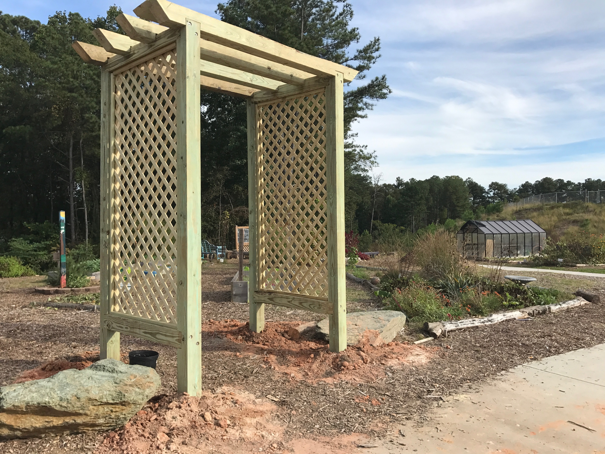
When asked if the final product was what she had envisioned, Ms. Calderon admitted it was “a lot taller” than she thought it would be; however, when she stood further away and saw it in the context of the expansive garden area, she suddenly smiled and said, “I'm proud of it.” As she should be – how may 10th graders have a completed design/build structure on their resume? This one will be around for a very long time, a beautiful tribute to nature, youthful dreams, and an empowering community.

Built on October 21, 2017, Summerour's new garden entry arbor is over 10' tall x 6' wide x 4' deep, welcoming students and the community into the gardens and forest trails that comprise the school's extensive outdoor classroom.

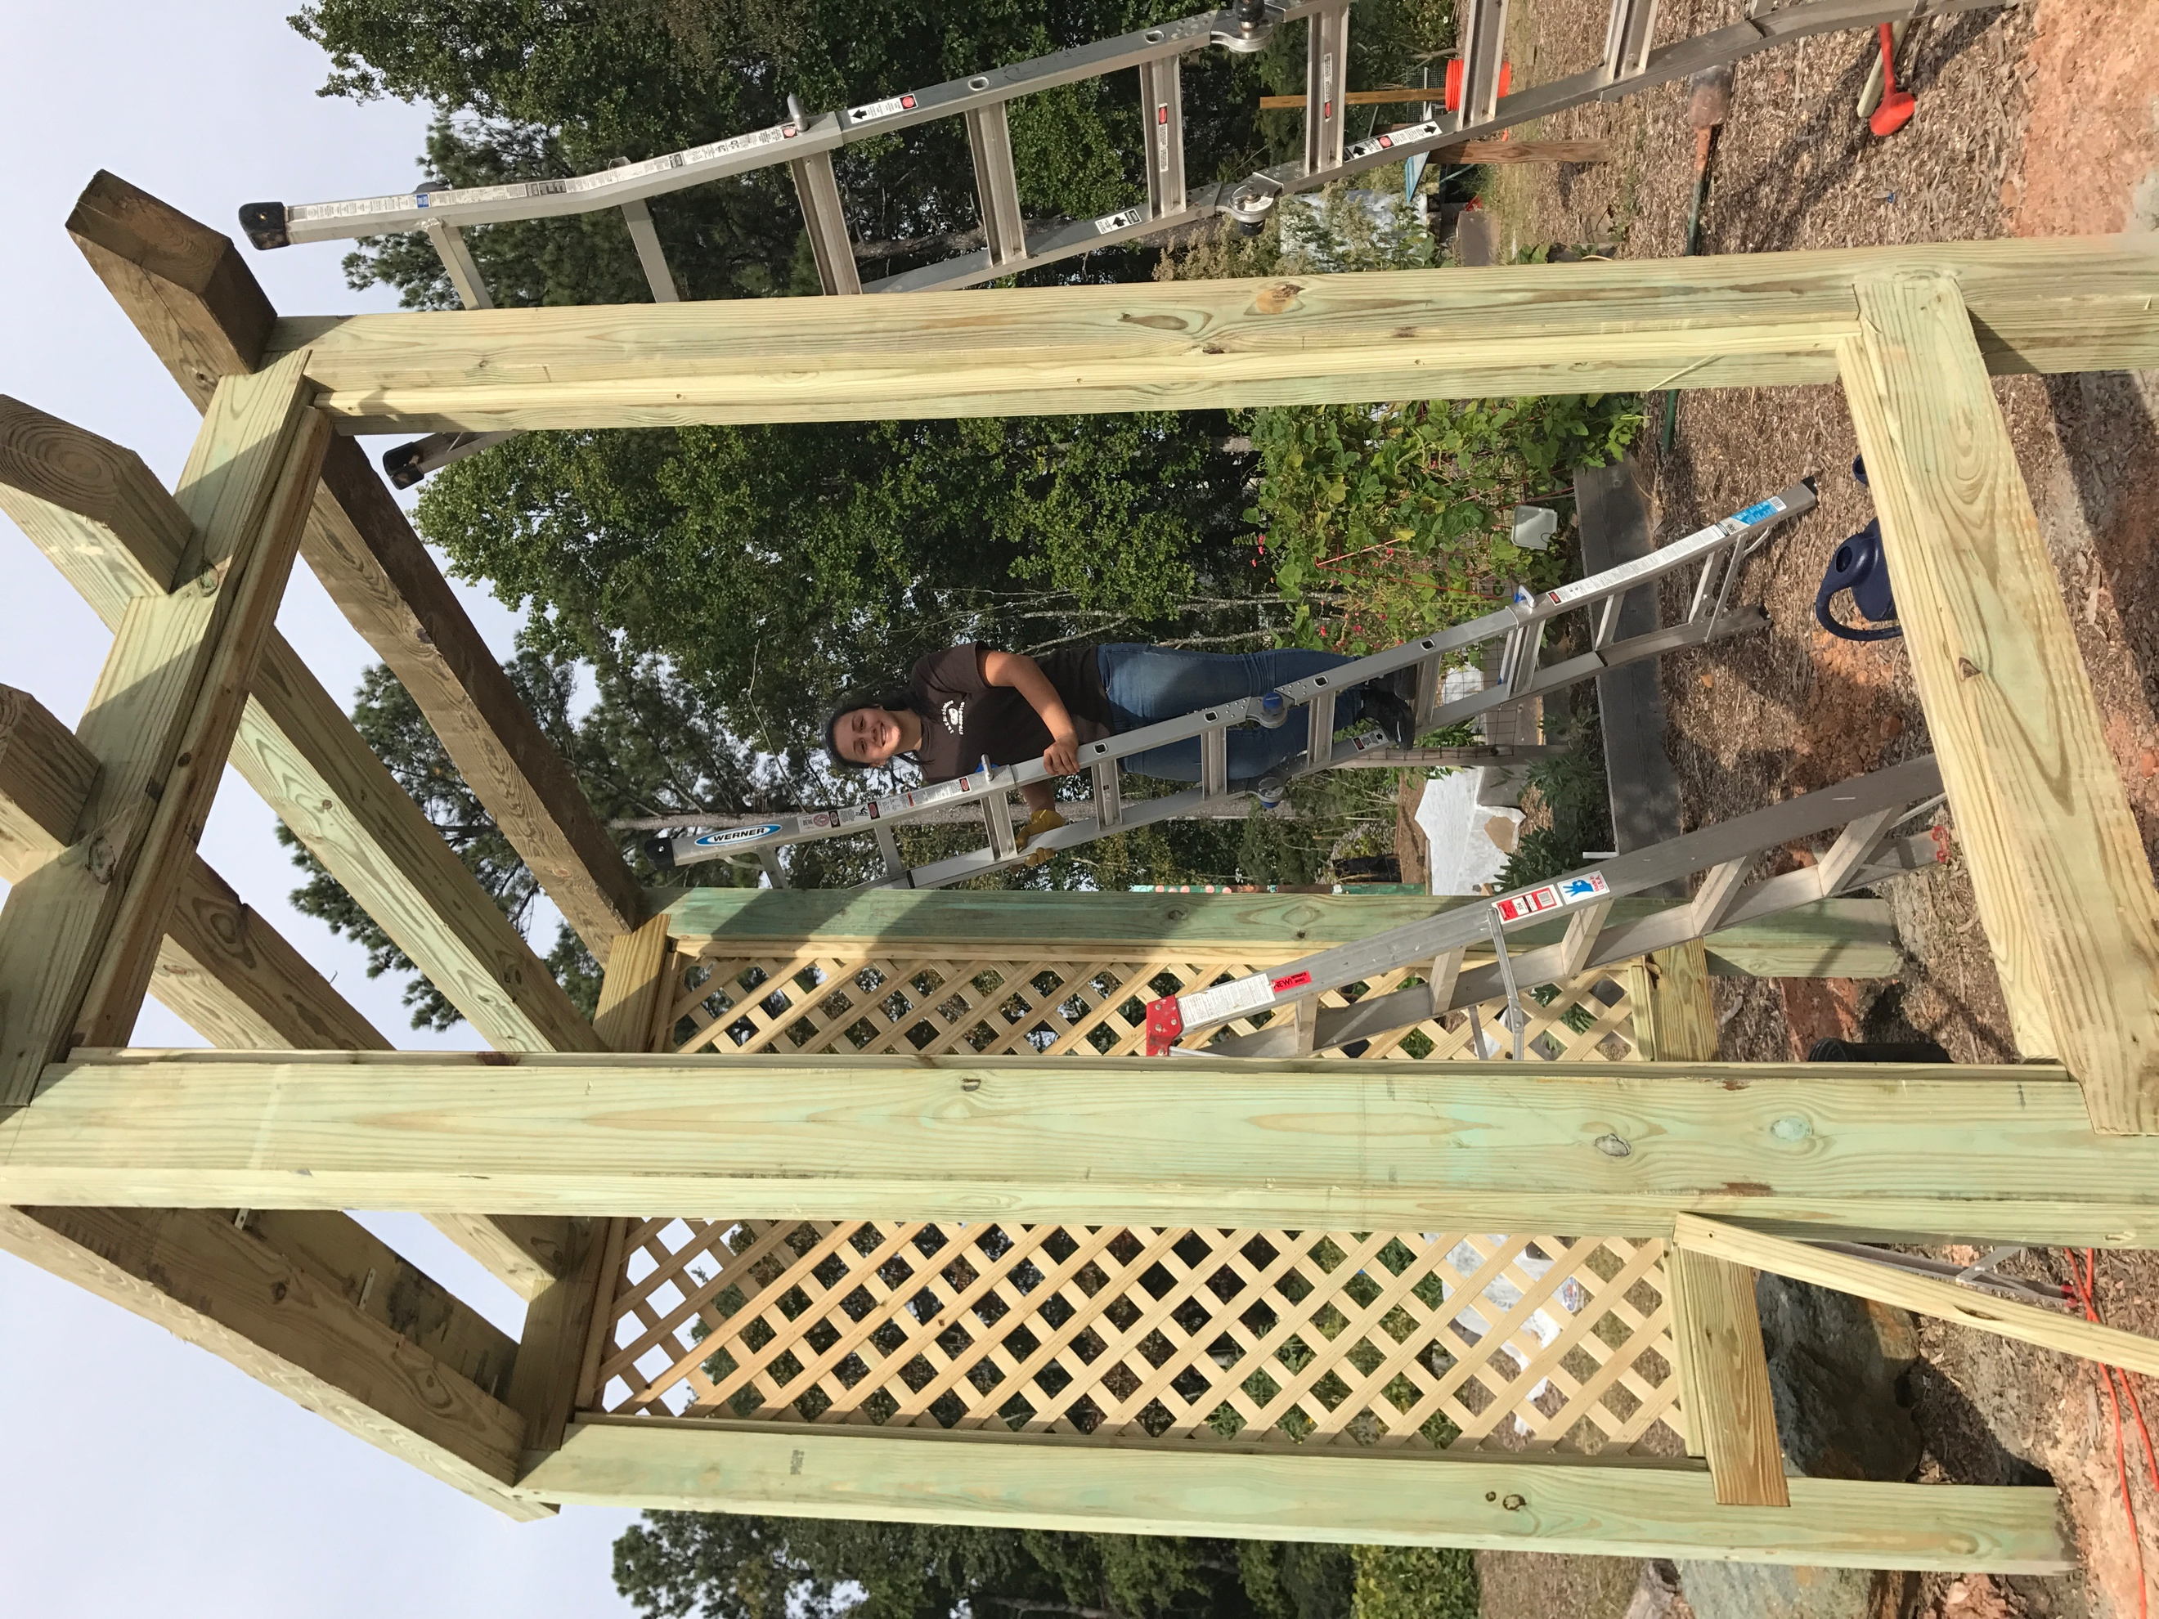
Under the tutelage of several community mentors who volunteered their time and skills, 10th grade student Kenia Calderon designed and helped build an arbor that will welcome students to Summerour's Environmental Education Center for many years to come!

