Holiday 2018 gathering – more than just a party

December 10, 2018 - The 2018 holiday gathering held in Norcross at the Kudzu Art Zone is another example of the generosity of Norcross Garden Club members. Once again, the club was asked for donations to pass along to the Norcross Co-op Ministry. This year, members donated a total of 165 new items: 57 hats, 59 pairs of gloves, 17 hat & glove sets, 14 scarves, 15 pairs of socks, and 3 pairs of slippers.
The group enjoyed some light jazzy music by Raiff Ellis once seated for the meal. The food provided by Bleu House Café offered spinach and provolone stuffed chicken, squash casserole, oven roasted potatoes and veggies, Sunshine salad, and an assorted dessert platter. Members brought wine to share.
The tablescapes were provided by Shante Hassel and Leanne Penman. The raffle drawing encouraged members to answer six qualifying questions to participate. Here are two examples:

- As responsible citizens and members of The Garden Club of Georgia, give the 3 key areas we strive to promote and fulfill _________, __________, ____________
(Hint: This is the Garden Club of Georgia’s Mission Statement) The Answer is: Beautiful, Conservation, Education.
- Put your name here if you served as a hostess, greeter, provided the inspiration/devotional or provided table decorations from September 2018 until now.
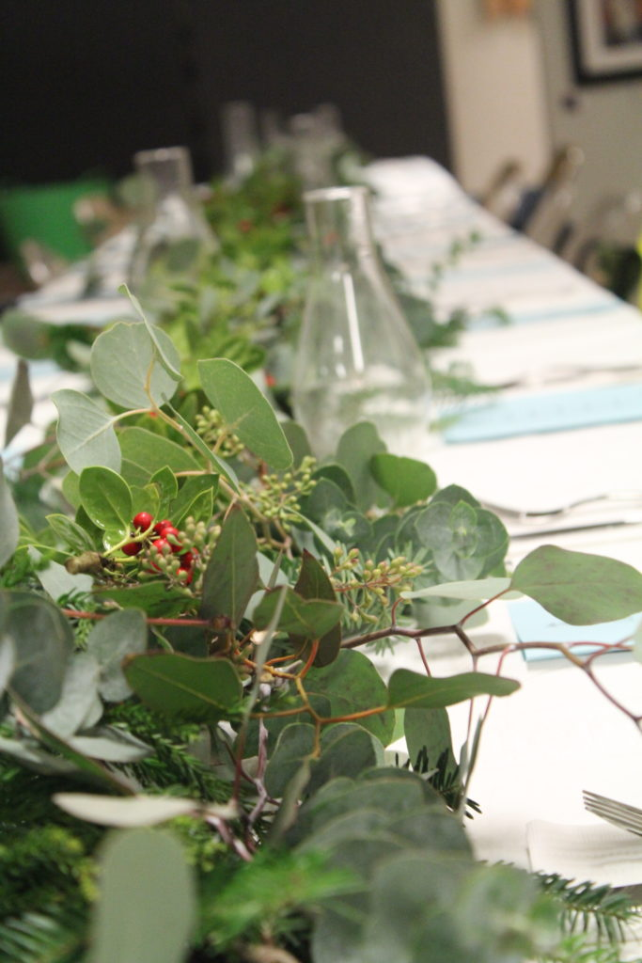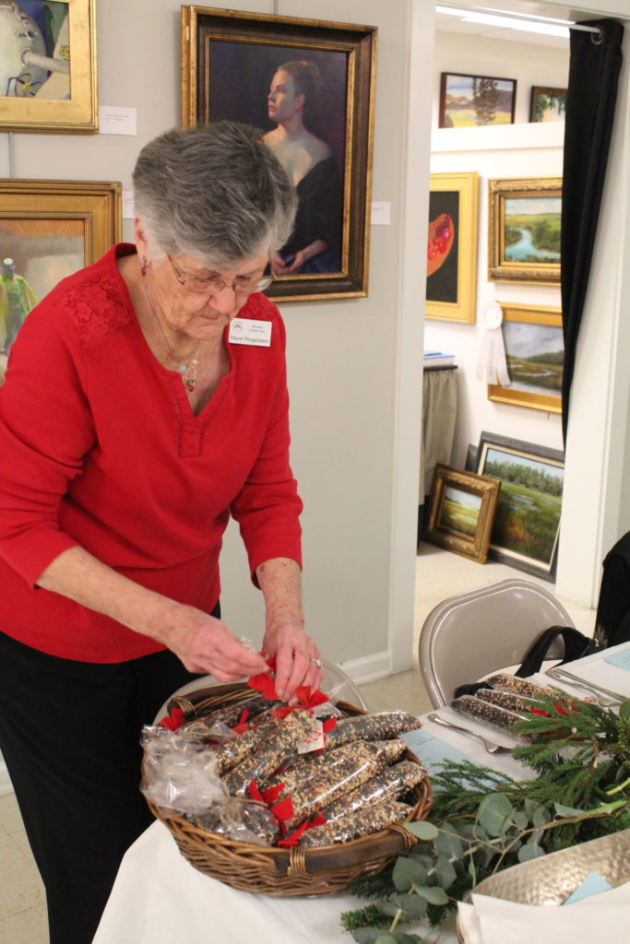
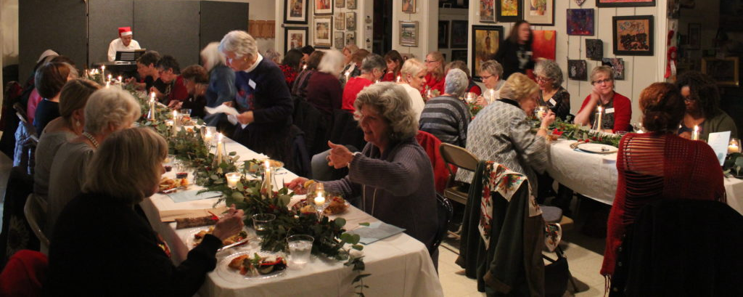

Photos by Jolyn Barrow
Seeking Eden
JANUARY 14, 2019 The Norcross Garden Club January “Lunch & Learn” Program was presented by Staci Catron and Mary Ann Eaddy who recently updated and expanded the book entitled Seeking Eden, A Collection of Georgia’s Historic Gardens. Stories of some of Georgia’s most fascinating historic landscapes were shared to a very full Clubhouse cottage. All Georgia gardeners should hear this fine lecture. We each went away with “an awareness of, and appreciation for Georgia’s rich garden heritage.”

FEBRUARY 19, 2019

Save the Date

NORCROSS GARDEN CLUB Annual Plant Sale
Friday, April 12 & Saturday, April 13, 9am to 5pm
33 College Street, Norcross, GA 30071
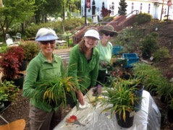
Sandy Pagano, Leanne Penman and Cathy Nelmes pot plants for the annual Plant Sale.

