Alstroemeria Holiday Topiary
Supplies List
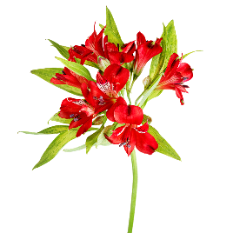
You can purchase Alstroemeria at Kroger, Sam’s Club or a flower wholesaler like Hall’s of Atlanta.
Moss or Trick Dianthus

Interested in taking classes at https://hallsatlanta.com/design-school/ ?
Say SHANTE HASSEL referred you and you will receive $50 off your class!

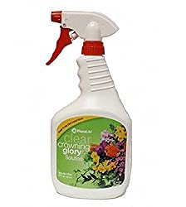  Crowning Glory Floral Spray for Long Lasting Arrangements  https://amzn.to/32J9wib | 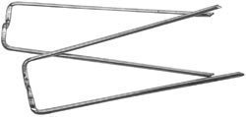  Oasis 2” Greening Pins to keep the moss in place https://amzn.to/3pp8oKk | 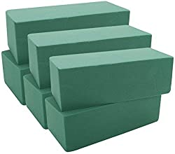  Oasis wet floral foam bricks  https://amzn.to/3psaclF
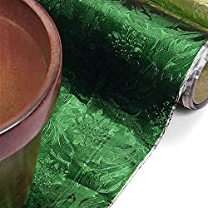  Moss Green Embossed Floral Foils  https://amzn.to/3kubUPK | 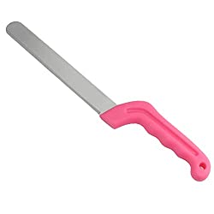  Cutting knife for floral foam  https://amzn.to/3nipgkb | 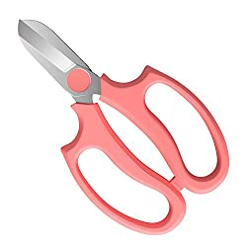  Floral Shears  https://amzn.to/32FRZaJ
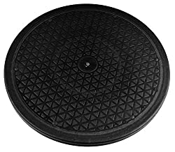  Heavy duty Lazy Susan  https://amzn.to/2UoThlP | 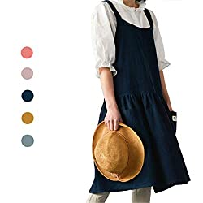  Apron  https://amzn.to/3psRoTF | 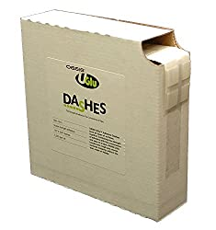  Oasis U Glue Dashes  https://amzn.to/38GwN8s
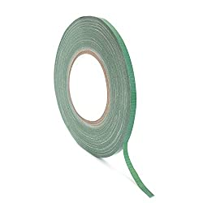  Floral Tape  https://amzn.to/2UoHeF9 | 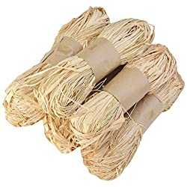  Raffia  https://amzn.to/3ksTdfz | 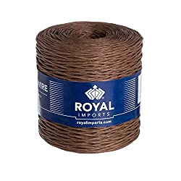  Floral Bind Wire  https://amzn.to/3lyJ3eE
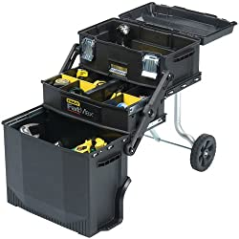  Fatmax Mobile Workstation  https://amzn.to/32Hnn8M | 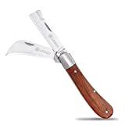  Knife  https://amzn.to/3oxT4cX | 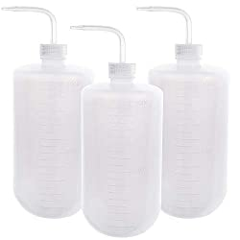  Wash Bottles  https://amzn.to/38NjLpo

