MISSSION: BEAUTIFICATION … CONSERVATION … EDUCATION

Planting and Growing with Challenges
June 2022
Volume: VI Number: 9
Gardening Issue: Linda Doiron, Editor

Environmental Edition: May, August, November, February - Mary Lovings, Editor
Gardening Edition: June, September, December, March – Linda Doiron, Editor
Landscape Design: July, October, January, April - Suzanne Finger, Editor

Garden Photography- The Way that You See Them
We are setting heat records this June in Georgia. After working so hard during the spring (and with the help of a little water), our gardens should be near their summer prime. I thought it might be interesting to learn about taking photographs of your garden so that you can reward yourself for a job well done.
This article will provide a number of tips and tricks to get the best photos using your cell phone. Some of the tips will apply for those that have wonderful Nikons and other cameras, but since most of us have a cell phone camera, I thought it best to focus on this device.
Garden photography is a great way to enjoy your garden and improve your photography skills. The most important and basic concepts to understand include how to compose your photo, use of a grid, the best light and weather conditions, and color theory.
Simplify Your Choice of Subjects. A garden is the sum of its parts so try to include the subjects that give your garden its personality such as flowers, buds, seed pods, leaves, fruits, pollinators, vegetables, trees, handmade objects or structures.
Flowers are always fun to photograph, and this is a great time of the year to capture favorite ones in your garden. But when composing a photo, remember to simplify your choices by finding a focal point. If you try to capture too many elements in your composition, it may result in clutter and a viewer will not know where to look.
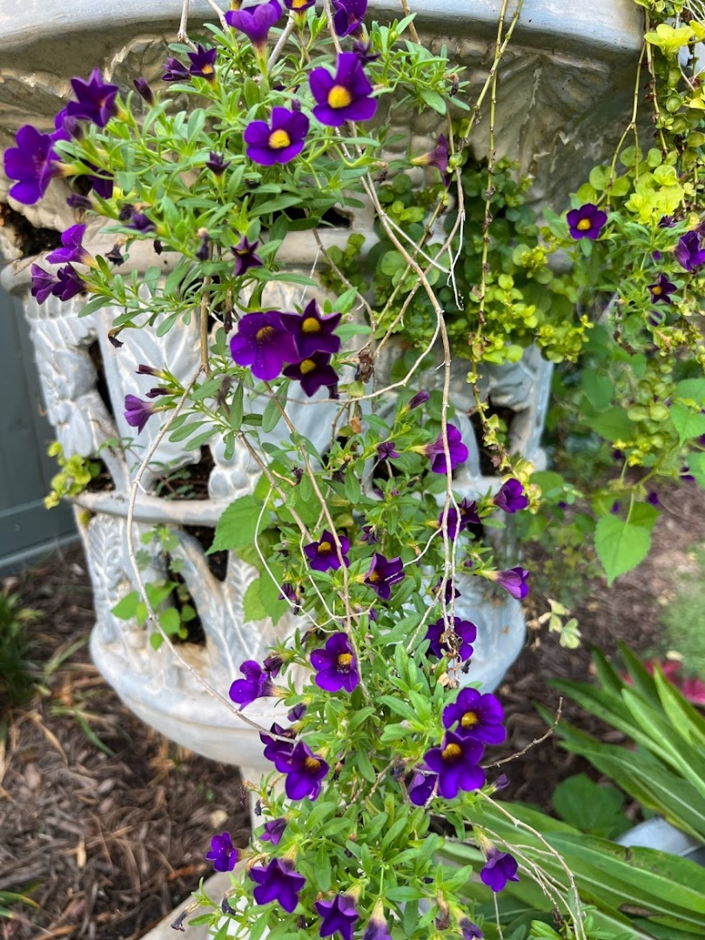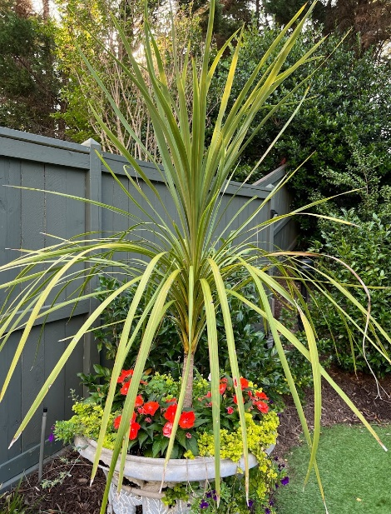
The photos above show my point of view from two perspectives shooting flowers from the same planter. I like the first one much better.
Here are a few proven techniques:
- Try to use only one or two elements to focus on and allow some breathing room or “negative space”. Negative space is that part of a photo where nothing is really going on such as an empty sky. The point being that an empty sky doesn't draw the eye, instead it helps a viewer to focus on the main subject.
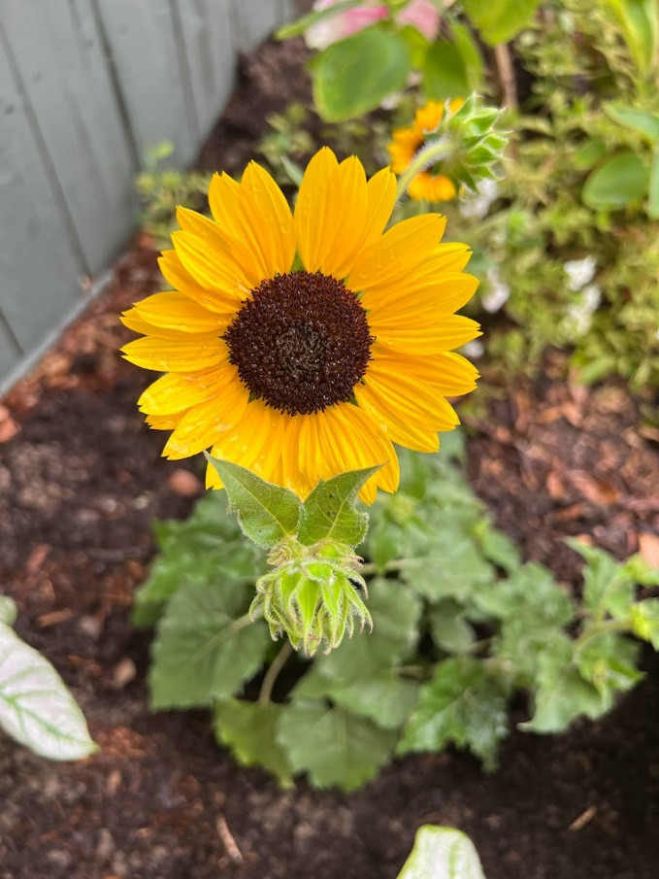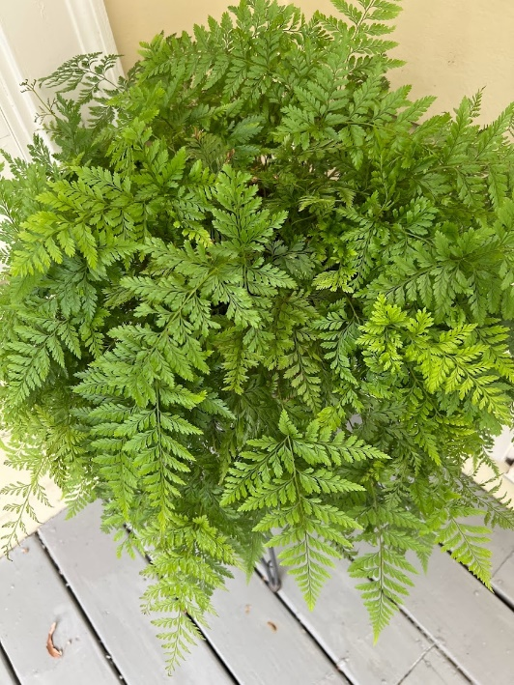
- Get low to the ground and near the subject of your photo. It will make your subject loom large and can be a simple method of getting a plain background.
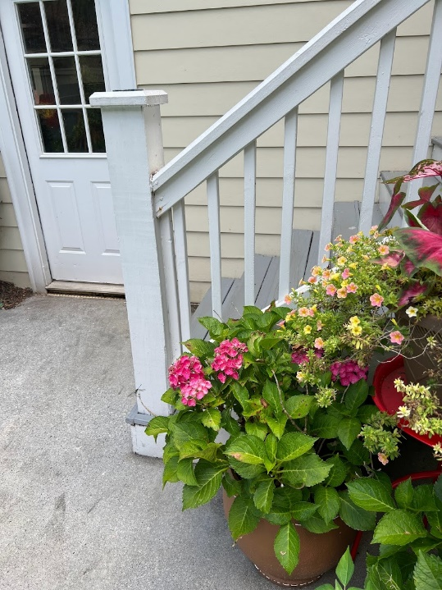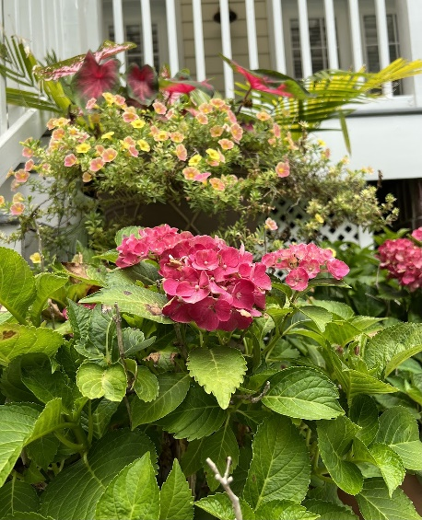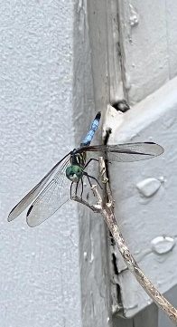
- I'll call the one above my “dragonfly” tip. (The dragonfly is found above near the end of the baluster on the tip of a stem in the first picture). The second photo starts low from the stem that the dragonfly was on and points upward.
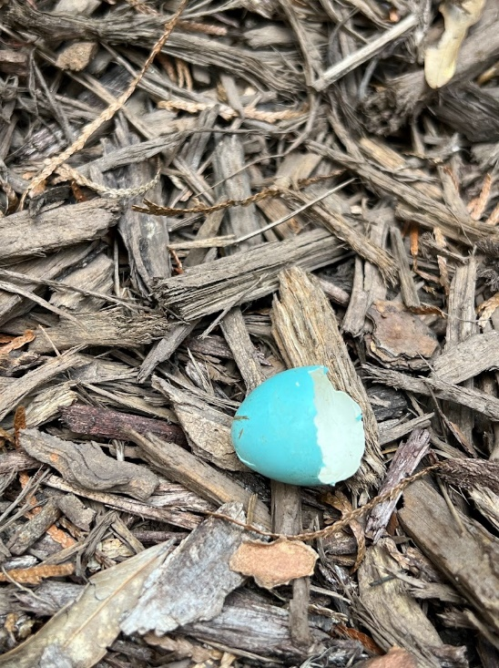
- Sometimes a plain background can help avoid distracting elements so try changing your position to find new perspectives.
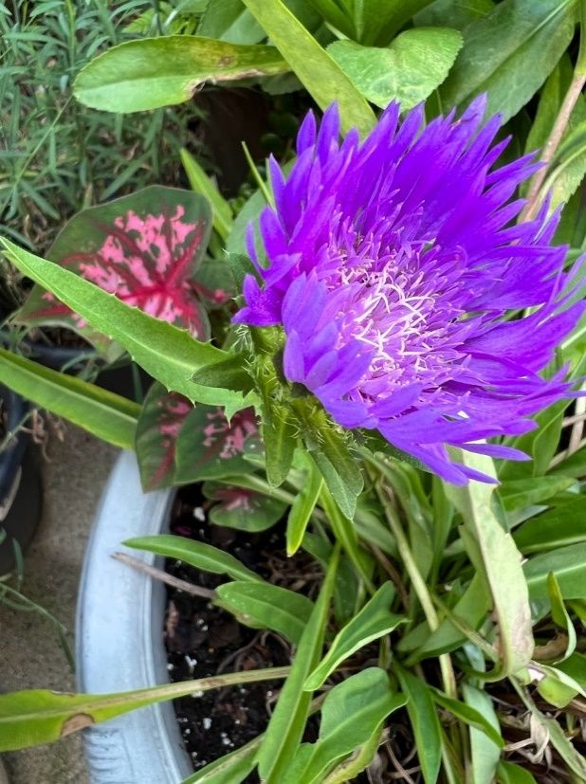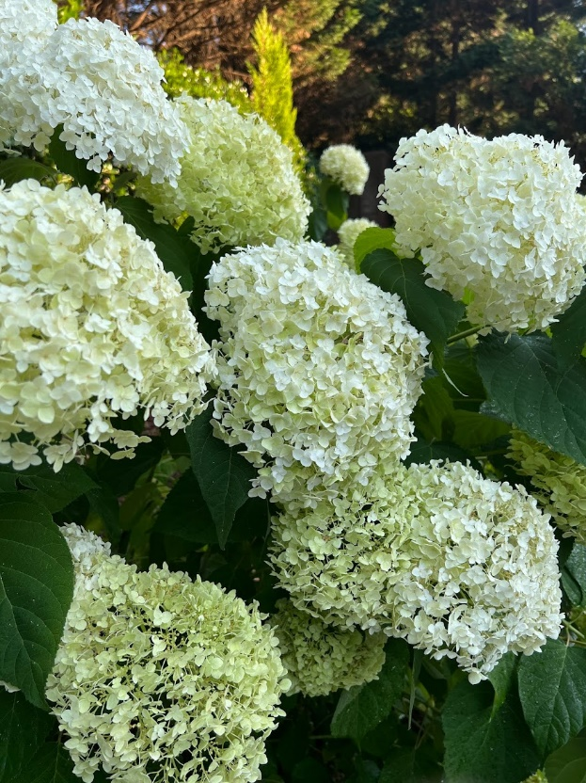
- Stand behind or to the side of flowers shooting from a low angle aiming your phone up towards the sky. It gives the flowers a more unique perspective because the bright light behind the flowers will shine through any semi-transparent petals revealing color in detail that you wouldn't otherwise be able to see. Above is a Stokes aster and Incrediball hydrangea.
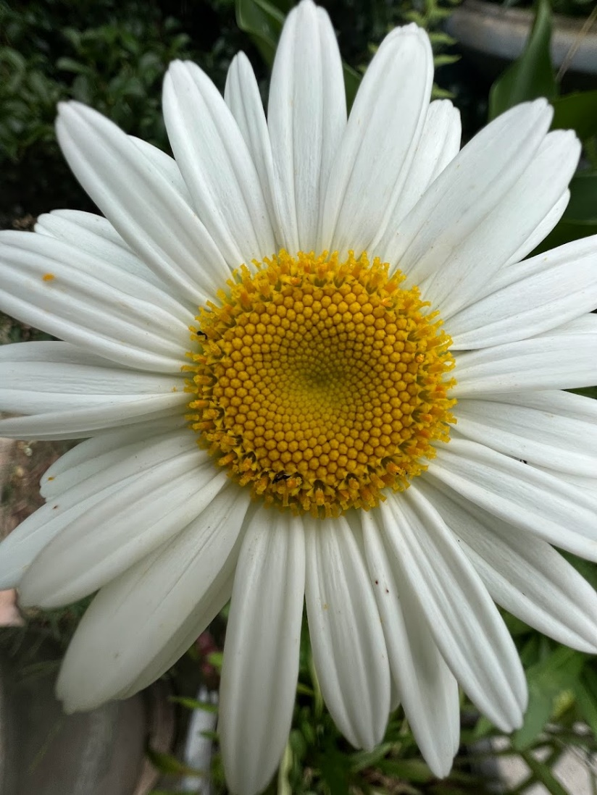
- Move in close and fill in the entire frame with a single flower which often creates a more powerful photo. Be aware that your phone won't be able to focus if it's too close so if the entire photo appears blurred pull the phone back and then tap to focus again.
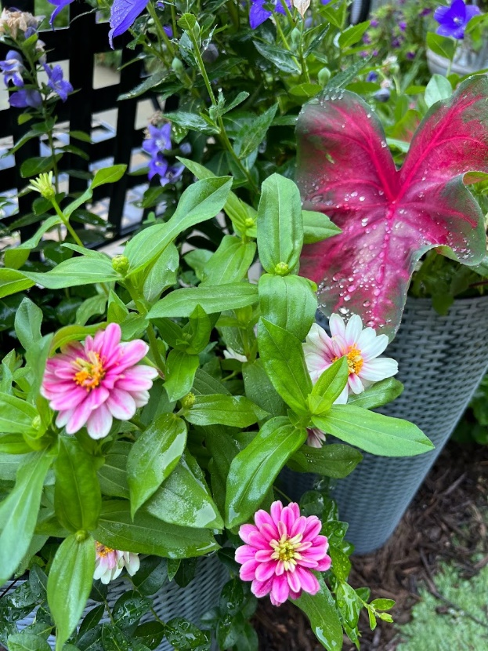
- Capture water droplets on flowers as they add sparkle to your photos and compliment your subject.

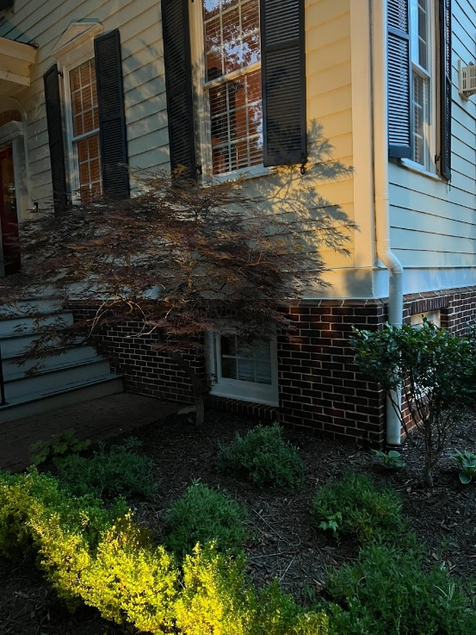
- Another beautiful technique is to photograph subjects capturing their shadows on a wall. My Japanese maple (above) always casts a great shadow on the front of the house.

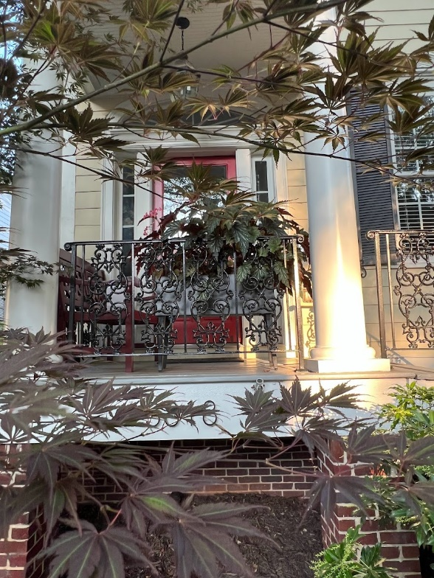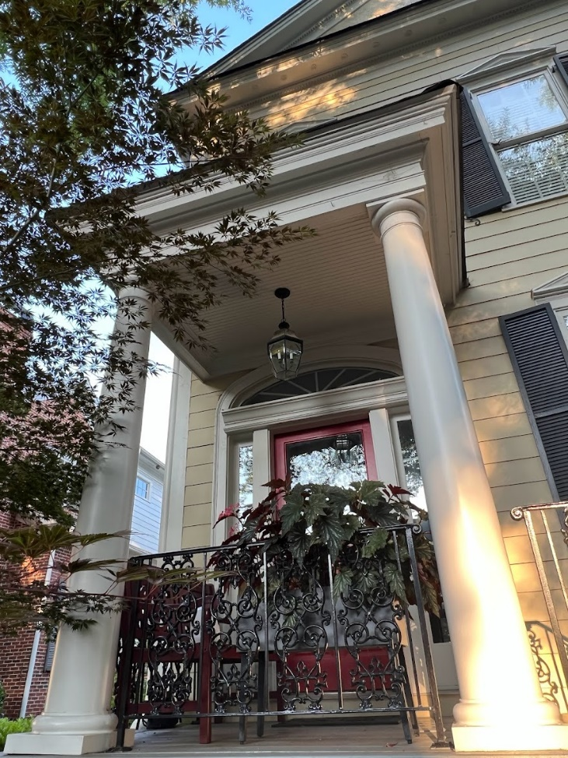
- Turn your phone upside down and take a picture. When you turn the phone upside down you change where the lens is in relation to the image, and the results are often more artistic. Note some older phones will not allow a picture to be taken upside down, but mine does, and here is an example of two pictures, the first one where the phone is right side up, and the second where the phone is upside down. I much prefer the second one.
Diversify Your Photo Collection.
Sometimes we get so focused on the details of a single flower or subject that we forget to step back and look at the wider surroundings. An entire field of vision can create a wonderful complete story of your garden. Dynamic images are created by providing a sense of depth that leads the viewers’ eyes from the foreground to the background. To accomplish depth in a photo and make the landscape feel spacious, use leading lines that draw the eye into the photograph such as garden paths, fences and roads or use subjects in the foreground. I’ve set out below two pictures, one a road leading line and the second, a great subject-my best garden buddy, Cammie.
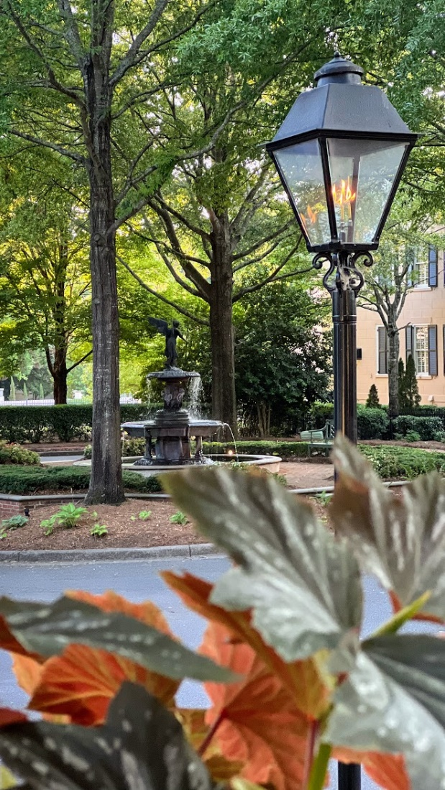
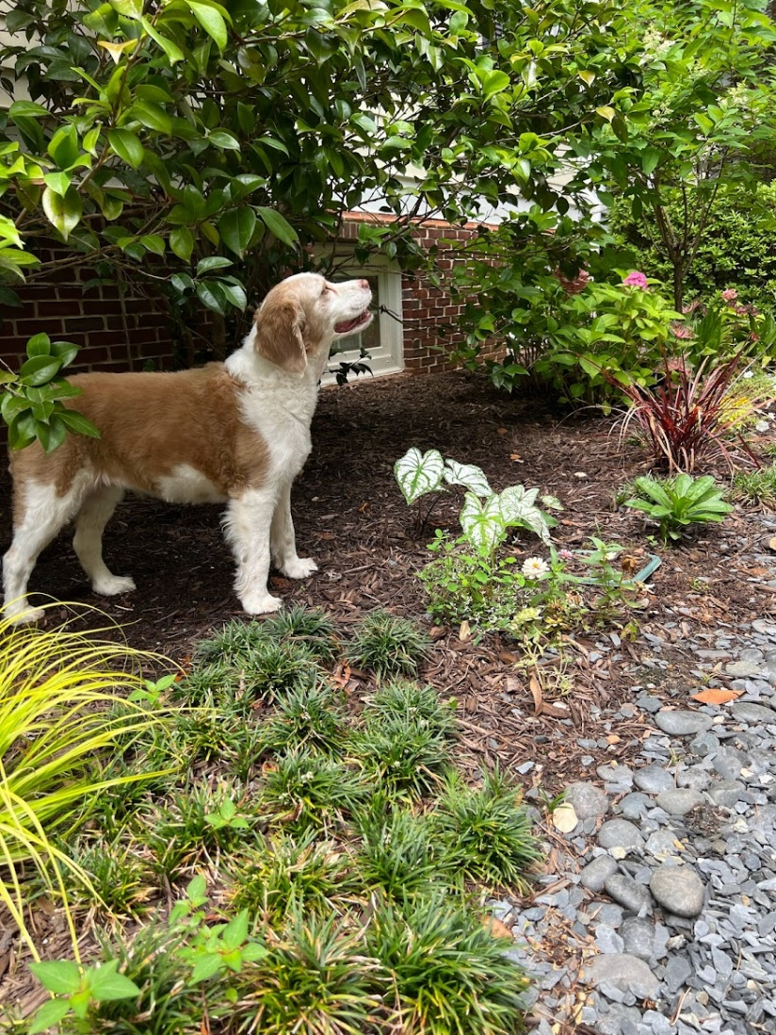
You can also add diversity by taking photos that go from big to small using wide angles or medium shots to emphasize certain areas. Most phones have an option for panoramic photos. These are extremely wide photographs made by stitching together several normal photographs on your phone. You'll see directions on the phone’s camera screen showing how to move your phone slowly from left to right to take a panoramic shot. Panoramas are fantastic for capturing sweeping vistas that are just too big to take in a normal image. For best results, don't include too much of the foreground in your panorama as foreground elements get distorted so it's best to avoid including these if you want sweeping breathtaking images.
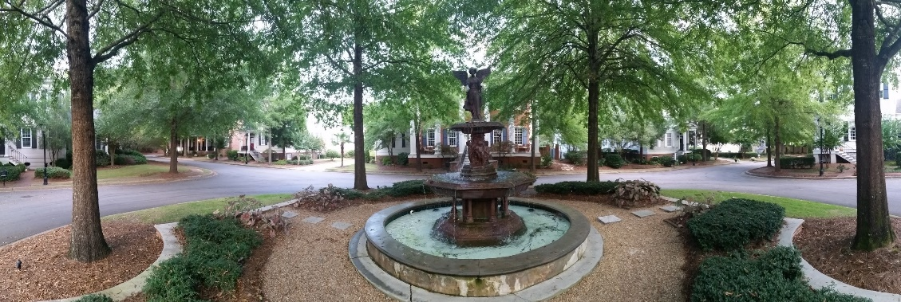
Horizons are Important. Probably the best bit of advice I have is to get the horizon straight because nothing ruins a picture more than a slanted horizon. Most phones now have a grid setting to help you align the horizon in your photos. For iPhone, tap settings, then camera, turn on grid. For android phones, tap camera, then settings, tap more settings, tap grid. Make sure that the 3x3 grid is selected.
There is a composition rule called “the rule of thirds” to help create beautiful photos by arranging the elements in a photograph. The rule suggests that an image should be divided into nine equal parts. Your important elements should be placed along these lines or their intersections to create more energy and interest than simply centering the subject.
When photographing a sunset or sunrise use the top or bottom horizontal gridline. Horizons along the top and bottom guidelines with a subject in the foreground is generally a beautifully composed photo. Did you set up your grid as suggested above? If so, you will see the rule of thirds grid on your phone, and you’ll be able to use it to create awesome photo compositions. There are, of course, other composition methods, but the beauty of the rule of thirds is its simplicity.
What if you've already taken slanted images? There is a way to rescue these photos by simply opening the photo on the Photos app, tap edit, then select the rotate tool, and hold your finger on the number scale that appears below your image. Your phone may also allow you to correct a horizon problem through cropping a photo.
Early Morning or Late Afternoon Light Conditions. Early morning or late afternoon offer the best lighting of the day-soft and golden. Shooting during these times limits the harsh bright light of the midday sun that comes with a whole host of issues such as strong shadows, blurriness or overexposed images. Overcast days also work well because the light is naturally soft and diffused. Below is a photo of my favorite tree, the Empress of China Dogwood. The semi-evergreen leaves and flowers trail upwards for fifteen feet during the month of June.
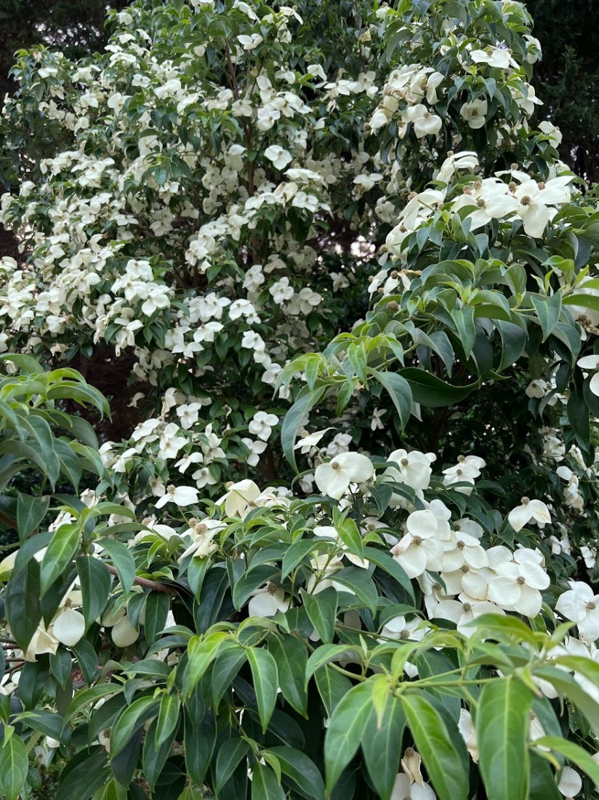
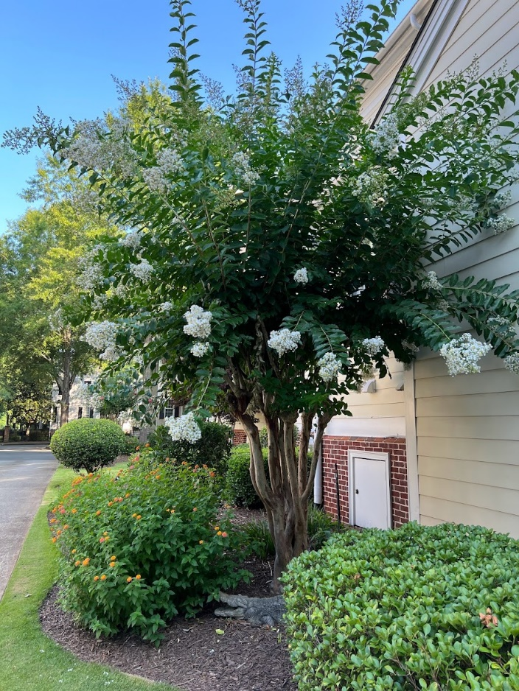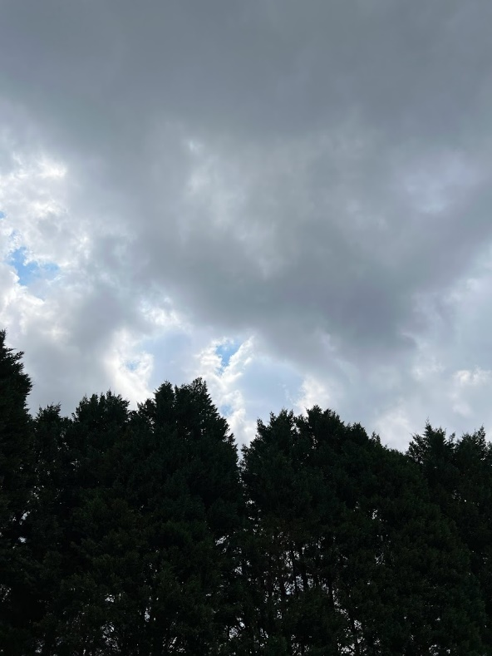
Landscape photography isn’t just about getting great shots of the land. Pay attention to the sky to get interesting cloud patterns, sunrises and sunsets. Weather plays an important role in the overall composition and strength of your photos. Consider shooting moody images using a stormy sky, cheerful images using white fluffy clouds, or bring your photo alive with sunrise or sunset skies with clouds turning pink and orange. Above I have tried to capture a perfect blue sky, and on the right, possibly the only stormy cloud near my house during the last few weeks.
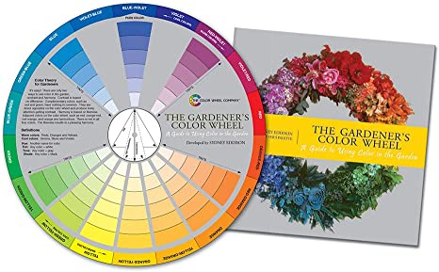
Color Theory- Gardens are full of beautiful colors and combining them in certain ways will make your flowers outstanding. Many stores sell a color wheel and would suggest that you add it to your garden planning process. There's a lot to color theory, and a wheel can give you the short cuts to color combinations that honestly deserve a whole book by itself. When you think of color, also look at other people's gardens or gardening books and consider the color palette of what is going to complement each plant or really stand out.
If you don’t want colors to overwhelm the eye, you can add a sense of peacefulness to an image by simplifying your color choices because sometimes, when it comes to landscape photography, less is more.
Other Phone Tips-I recently added a photo widget to my iPhone that selects photos to feature on my home screen. The widget helps me see my photos in a new and different way and it’s really a lovely addition. Press and hold an empty area of the screen, tap the + icon to open the widget menu, tap photos, select the size, and tap add widget. (You can remove a particular photo from the widget by pressing the photo from the widget, then share, then remove from featured photos or hide.)
This butterfly was in my garden over the weekend. With the help of Google Lens, I was able to identify it. Open the photo in the photo app, tap Lens, see results.
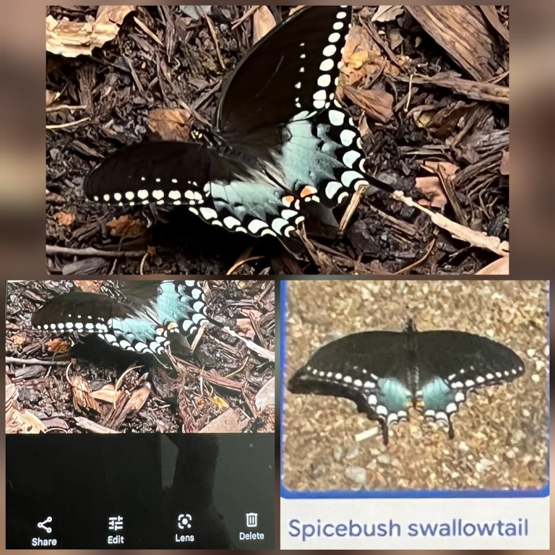
I downloaded an app called InCollage that allows me to frame my pictures in grids or templates. It’s very easy to use and fun to see pictures tell a story together. Below is an example from InCollage, dapper little fellow with green skin and blue eyes, before he saw me.
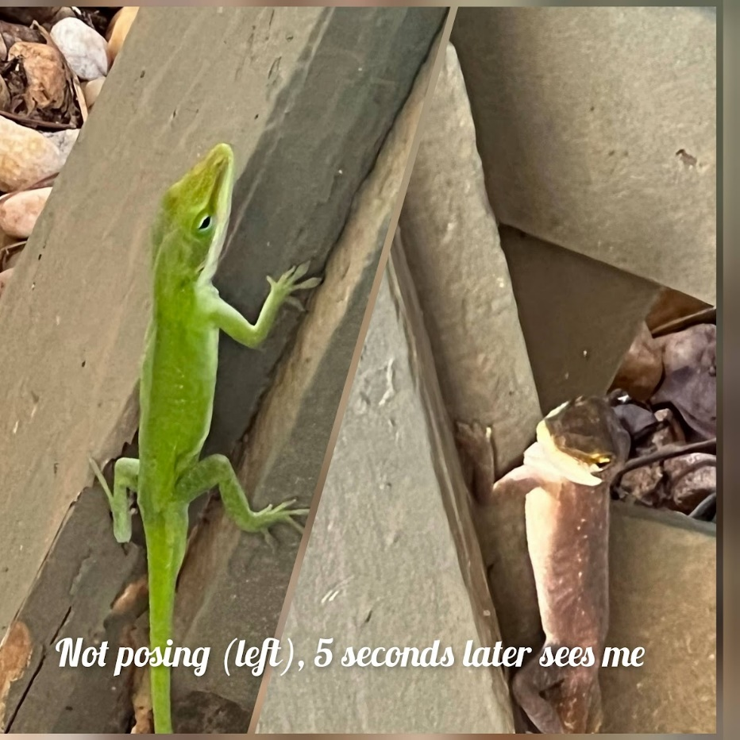
Not All Those Who Wander are Lost- (J.R. Tolkien)- Like gardening itself, garden photography is so much about the process and what you experience as you're doing it, that it may be the reason you fall in love with it. It gives you a reason to slow down and appreciate your garden. Actually, it’s wander-ful.
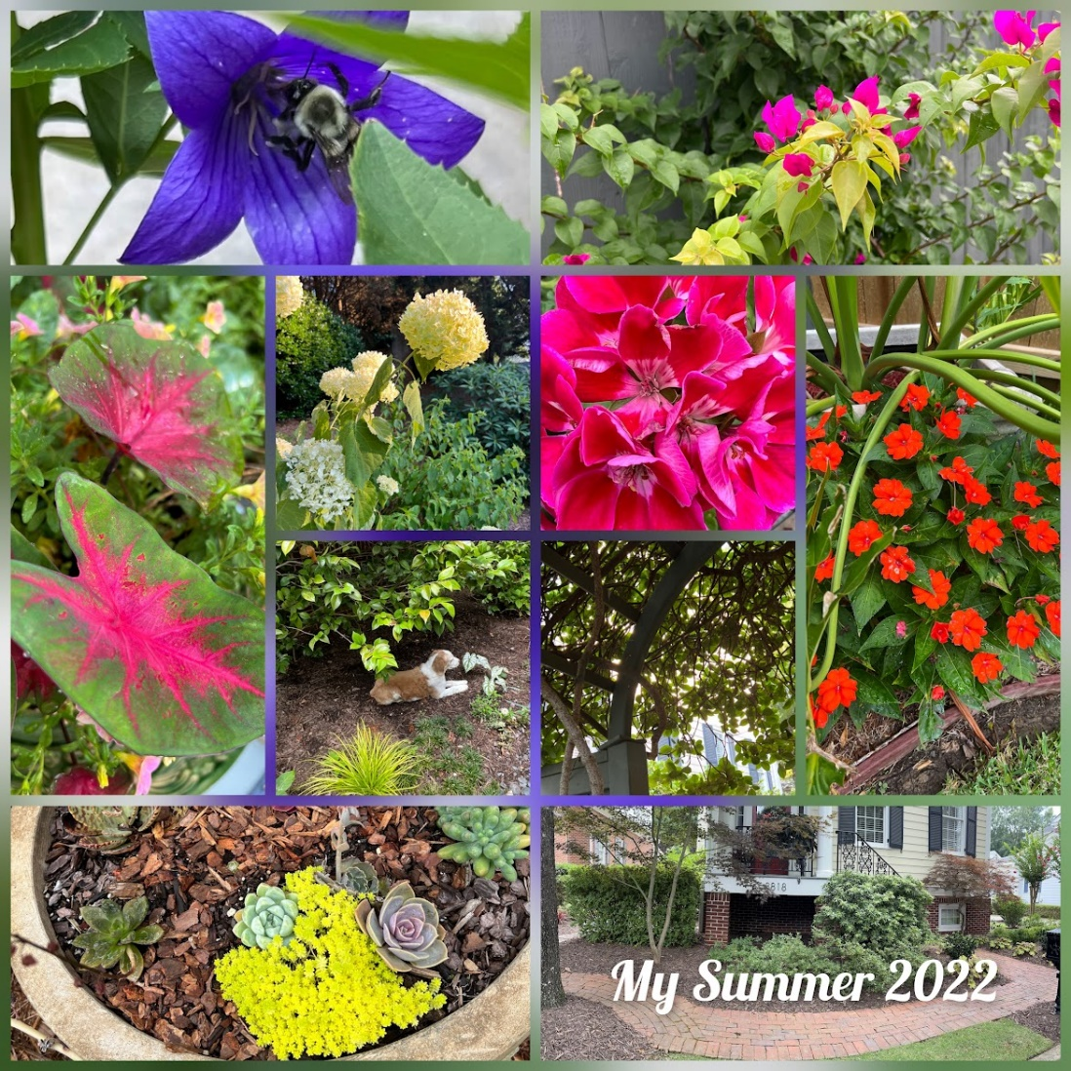
Be Well,

Linda Doiron
The Hokey Gardener

Be Well,

