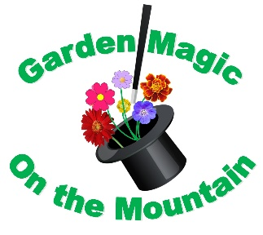
95th Annual Convention of the of The Garden Club of Georgia, Inc.
“Garden Magic on the Mountain”
April 18-20, 2023
Evergreen Lakeside Resort – Stone Mountain
Hosted by Dogwood District
Sponsorship/Donor Levels & Benefits

Platinum Sponsorship Level - $1000.00
*Recognition as a Platinum Sponsor on the Dogwood District Facebook Page
*Displayed as Platinum sponsor in the Garden Gateways Magazine Convention article – Spring 2023 issue which is distributed to over 9,000 members and associates statewide
*Displayed as a Platinum sponsor in the convention articles in Board Briefs newsletter – Winter 22/23 & Spring 2023 issues, which are distributed via email to all our clubs statewide.
*Displayed as a Platinum sponsor in convention articles in the Dogwood Dialogue newsletter – Winter & Spring 2023 issues, which are distributed via email to all our clubs in Dogwood District.
*Displayed as a Platinum Sponsor on Signage and Publicity at the convention – big screen at meal functions.
*Full page ad in electronic Program Book sent Statewide and to all attendees.

Gold Sponsorship Level - $500.00
*Recognition as a Gold Sponsor on the Dogwood District Facebook Page
*Displayed as Gold sponsor in the Garden Gateways Magazine Convention article – Spring 2023 issue which is distributed to over 9,000 members and associates statewide
*Displayed as Gold sponsor in the convention articles in Board Briefs newsletter – Winter 22/23 & Spring 2023 issues, which are distributed via email to all our clubs statewide.
*Displayed as Gold sponsor in the convention articles in the Dogwood Dialogue newsletter– Winter & Spring 2023 issues, which are distributed via email to all our clubs in Dogwood District.
*Displayed as a Gold Sponsor on Signage and Publicity at the convention - big screen at meal functions.
*Half page ad in electronic Program Book sent Statewide and to all attendees.
Silver Sponsorship Level - $250.00
*Recognition as a Silver Sponsor on the Dogwood District Facebook Page
*Displayed as a Silver sponsor in the convention articles in Board Briefs newsletter – Winter 22/23 & Spring 2023 issues, which are distributed via email to all our clubs statewide.
*Displayed as a Silver sponsor in the convention articles in the Dogwood Dialogue newsletter– Winter & Spring 2023 issues, which are distributed via email to all our clubs in Dogwood District.
*Displayed as a Silver Sponsor on Signage and Publicity at the convention - - big screen at meal functions.
*Quarter page ad in electronic Program Book sent Statewide and to all attendees.

Bronze Sponsorship Level - $100.00
*Recognition as a Bronze Sponsor on the Dogwood District Facebook Page
*Displayed as a Bronze sponsor in the convention articles in Board Briefs newsletter – Winter 22/23 & Spring 2023 issues, which are distributed via email to all our clubs statewide.
*Displayed as a Bronze sponsor in the convention articles in the Dogwood Dialogue newsletter– Winter & Spring 2023 issues, which are distributed via email to all our clubs in Dogwood District.
*Displayed as a Bronze Sponsor on Signage and Publicity at the convention - - big screen at meal functions.
*Eighth page ad in electronic Program Book sent Statewide and to all attendees.

Pewter Donor Level - $50.00
*Displayed as a Pewter Donor in the convention articles in the Dogwood Dialogue newsletter– Winter & Spring 2023 issues, which are distributed via email to all our clubs in Dogwood District.
*Listing in the Electronic Program book sent Statewide and to all attendees.

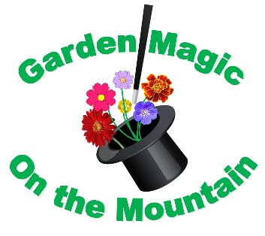
95th Annual Convention of the of The Garden Club of Georgia, Inc.
“Garden Magic on the Mountain”
April 18-20, 2023
Evergreen Lakeside Resort – Stone Mountain
Hosted by Dogwood District
Sponsorship/Donor Levels - Selection
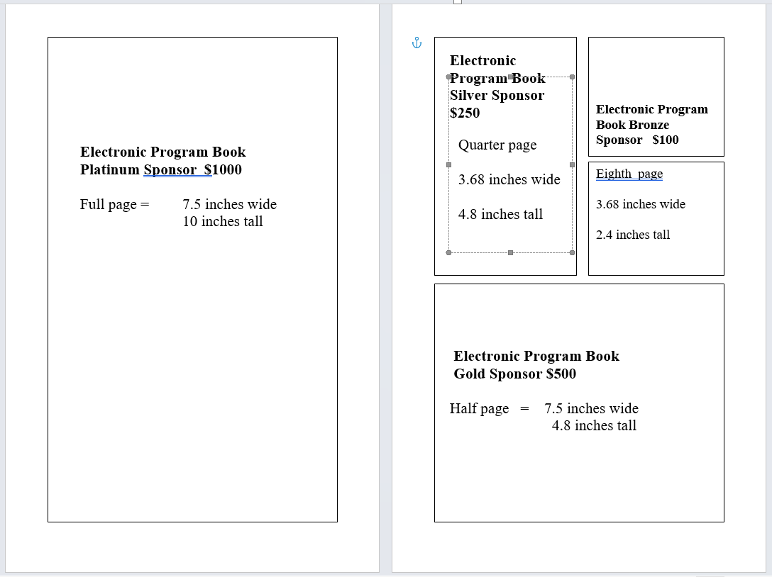
Please make your selection of Sponsorship level
 | $1000 | Platinum
 | $ 500 | Gold
 | $ 250 | Silver
 | $ 100 | Bronze
 | $ 50 | Pewter

Company/Club/Individual
Name
Contact person:
Street Address:
City/State/Zip
Phone
Email Address

Please make Check payable to GCG 2023 Convention - send all monies to:
Christy Novellas, Convention Co-Chairman
2170 Lafite Square, Smyrna, Georgia 30080
404-441-9964 cell
cnovellas@gmail.com

email graphics & ad copy to:
Barbara Bourque
b.bourque@comcast.net

