Design Needs for “Garden Magic on the Mountain”
Our Wonderful Floral Designers (JoAnn Jones, Maidee Spencer and Brenda Brettschneider) are creating fantastic magical table décor for our 2023 GCG Spring Convention.
Maidee Spencer would appreciate your help in obtaining some gnarly driftwood or cypress knees for
“Enchanted Forest” - unique pieces about 18” long or longer that could be cut down. If you have any:
- gnarled roots or driftwood or cypress knees
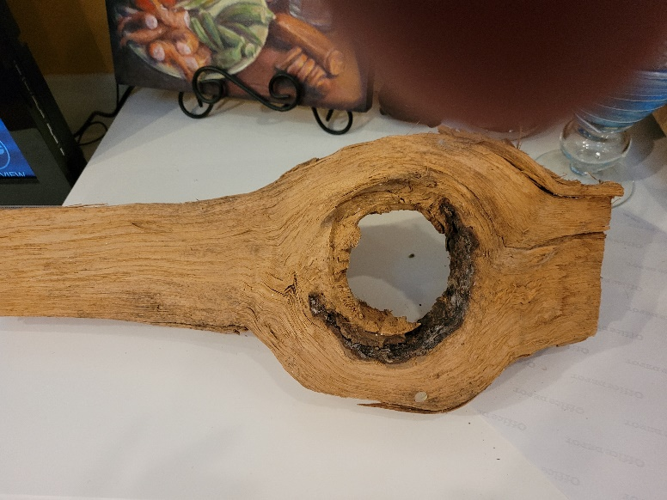
- Finished length should be about 18 inches. Could be larger that we could trim. Most important are knots & gnarls. They could have branches or holes.

Logistics- Whichever is more convenient. Two options:
#1 people could drop them off at the front desk at Holy Innocents Church, 805 mt Vernon Hwy (Riverside Dr exit off 285). Put my Name on it “Maidee Spencer”. Call or text me to say you are bringing it so I know to go to church and pick it up. Thx loads. Maidee 678.255.0462 ( new #)
#2 Drop off at Terry & Jane’s house 6590 Long Acre Drive, Sandy Springs. Put in carport with Maidee’s name. We will take all of them to Maidee in a bunch.
Need at least 12 by Nov 18th
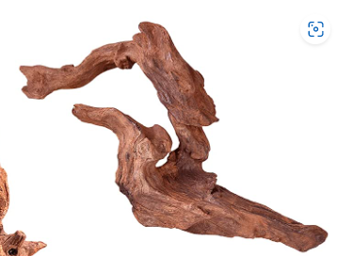
^{Examples:}
